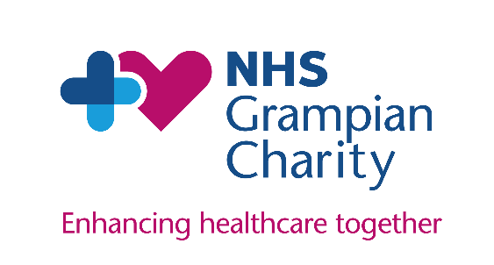
NHS Grampian Charity
Community Grants Programme Application Form

Please ensure you have read and understood our full guidance notes before starting to complete this application form. Please note, only fully completed applications will be progressed.

- Your Details
Primary Contact
Role in Organisation
Email
Telephone

- Organisation Details
Name and address of organisation

Second contact person
Role in organisation
Email
Telephone
Description of your organisation

Charity number
When was your organisation established?

- Name and summary of your proposed project
Please tell us what you plan to do:

What activities do you want to do?

How long do you expect it to run?

What difference will it make?

Why do you want to undertake this activity?

How will people know about the project?

How have you involved participants or beneficiaries in the development of this activity?

How do you plan to learn from the project to shape future work?

Is this something new or are you continuing something you have done previously?

What experience does your organisation have to deliver this project?

Maximum word count: 500

- Details of your project
How many people will be involved in delivering the project? | Staff: | Volunteers:
What are the proposed start and end dates of your project? | Start date: | End date:

- About your beneficiaries
How many people will directly benefit from your project?
What groups will benefit (e.g. older people, children, those living with disabilities, disadvantages communities, etc.)

Maximum word count: 100
How will people access your project/service? (e.g. GP referral, self-referral, other agency referral)

Maximum word count: 100
Where will the project be delivered?  Maximum word count: 100 | ☐ Aberdeen  ☐ Aberdeenshire  ☐ Moray  Please tell us where:

- Outcomes
Please select only one of NHS Grampian Charity’s Funding Priorities. This should be the one that best aligns with your intended outcomes | People have a better healthcare experience | ☐
 | People have better clinical outcomes | ☐
 | People are better able to manage their own health | ☐
 | People have an improvement in their mental or physical health | ☐
How will your project meet the funding priority? Please provide three indicators that you will measure to reflect this
Please tell us how you will evaluate your project

Maximum word count: 50

- Sustainability
How will the needs of those who have benefitted from your project be supported on its completion?

- Costs
How much funding are you requesting?
Please give a breakdown of the funding being applied for:

Item | Details | Cost
Total amount requested: |  | £

Please provide details here of any further funding required for this project, from other sources or from your organisation’s own resources
Please provide details of funding previously received from NHS Grampian Charity
Other information  (Please note, applications will not be progressed without the required information) | Please tick to confirm the inclusion of the following documents
 | Most recent signed, audited accounts | ☐
 | Constitution or governing document | ☐
 | Up-to-date Safeguarding Policy | ☐
 | Up-to-date Equalities Policy | ☐

- Signature
I confirm that I have read and understood the guidance and terms and conditions of NHS Grampian Charity’s Community Grants Programme, and that all the above information is true and accurate, and that I will notify the charity of any changes.

I confirm I have been authorised by the governing body of my organisation (the board or committee that runs your organisation) to submit this application and accept the terms and conditions on their behalf.
Signature
Date

Please double check and ensure that all sections of this form are fully complete, and the required information is attached before submission. Any incomplete forms will unfortunately not be progressed.

Forms must be returned in Word format only. Only information included in the application form will be considered, please do not send attachments or links other than those requested.

This form should be sent to us with your organisation’s name in the document title.

Please return your completed form to:
gram.charities@nhs.scot

- For Charity Team Use
Form checked and completed
Shortlisted
Panel score and feedback
Recommendation

