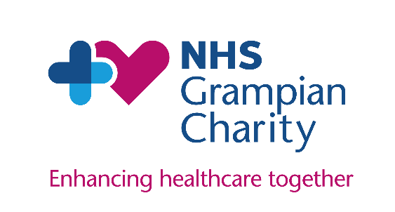**NHS Grampian Charity**

**Gift Aid Declaration**

Boost your donation by 25p of Gift Aid for every £1 you donate.

Gift Aid is reclaimed by the charity from the tax you pay for the current tax year. Your address is needed to identify you as a current UK taxpayer.

|  |  |
| --- | --- |
| 1. **Your Details** | |
| Title |  |
| First Name or Initial* |  |
| Surname* |  |
| House Number/Name* |  |
| Street Name |  |
| Town/City |  |
| Postcode* |  |
| **Please note details marked * are mandatory to make a valid Gift Aid claim** | |

|  |  |
| --- | --- |
| 1. **Donation Information** | |
| Donation Amount | £ |
| Ward or Department donation is being made to |  |

|  |
| --- |
| 1. **Declaration** |
| Yes, I am happy for all gifts of money that I have made to NHS Grampian Charity in the past four years and all future gifts of money that I make to be Gift Aid donations. NHS Grampian Charity will reclaim 25p of tax on every £1 I give.  I am a UK taxpayer and understand that if I pay less Income Tax & Capital Gains Tax it he current tax year than the amount of Gift Aid claimed on all my donations across all charities, it is my responsibility to pay any difference.  I understand that Gift Aid is claimed by NHS Grampian Charity from the tax I pay for the current tax year.  **Signature:** **Date:** |

|  |
| --- |
| 1. **Further Contact** |
| NHS Grampian Charity would like to keep you up-to-date about the work you are helping to make possible. If you are happy to receive our newsletter, please tell us your email address here: |

Please return your completed Gift Aid Declaration to NHS Grampian Charity by:

* Passing it to the person or department you have made your donation to;
* Scanning it and emailing it to [gram.charities@nhs.scot](mailto:gram.charities@nhs.scot);
* Sending it to us by post to: NHS Grampian Charity, Westholme, Woodend Hospital, Queens Road, Aberdeen, AB15 6LS

Please do not hesitate to contact us via any of the above should you wish to cancel this declaration, or if you change your name or address.

NHS Grampian Charity is a Scottish Charity, SC017296, regulated by the Scottish Charity Regulator (OSCR).

**Thank you for your continued support.**